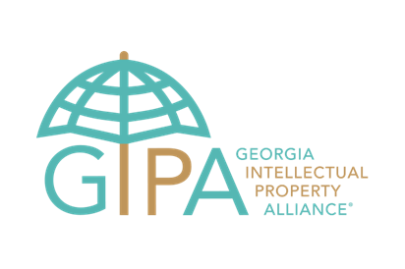

April 26, 2021

**Nurturing Atlanta’s Youngest Innovators in Celebration of World IP Day!**

**#WorldIPDay**

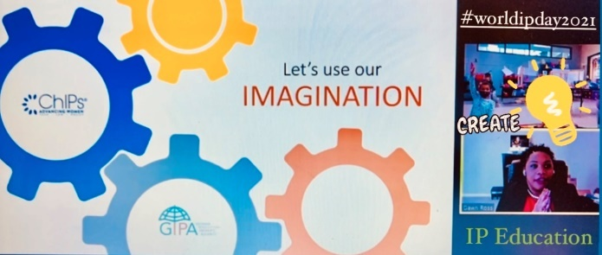

***“Have you ever created anything?”*** Asks Dawn Ross, Patent Attorney and co-owner of The Owens Ross Law Firm in her presentation about Intellectual Property (IP) to a kindergarten class at The Midtown International School (MIS) this morning in Atlanta, Georgia. The kids yell out *“A Drawing! A Craft!…I created a beautiful city!”* The classroom is a buzz with their virtual guest as they kick-off a full week of IP education!

Volunteers from The Georgia IP Alliance® (GIPA #gaipalliance) and the Atlanta Chapter of the Chiefs in IP (ChIPs) have come together this week to teach intellectual property to Kindergartners at the Midtown International School (MIS) in celebration of World IP Day!

Every April 26, we celebrate World Intellectual Property Day to learn about the role that intellectual property (IP) rights play in encouraging innovation and creativity. Every business starts with an idea that took shape in someone’s mind and made its way to market. With IP rights you can turn an idea into a business opportunity, generate value, create employment and enrich the choice of products available to consumers. With IP your business can flourish and your community can thrive!

“Our children are the future inventors, innovators and future business leaders! Thankfully Georgia has resources like GIPA that can provide support to school systems to implement IP into their curriculum,” expresses Tarianna Stewart, MIS parent and IP professional at IBM. “It’s wonderful to know that my child is in an academic environment that encourages children of all ages to learn about IP!”

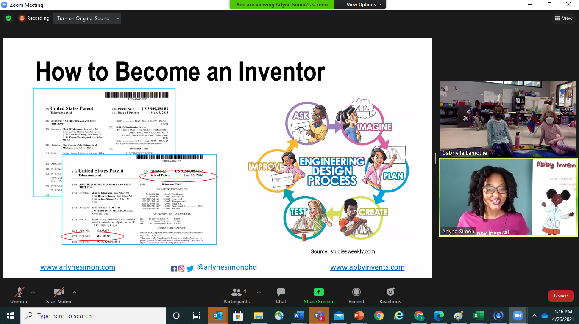

The kids also had a “visit” from inventor and author, Dr. Arlyne Simon, who believes that “anyone can be an inventor. It's never too early to learn about the magic of inventing." She shares a message about the engineer design process, showcasing diversity in innovation in her celebrated books @abbyinvents.com, where inspiring kid-inventor Abby solves problems and inspires young inventors!

Teaching kids from a very young age that their ideas have value is imperative for prosperity. And, some of Atlanta’s best intellectual property professionals have committed to teaching kids about intellectual property, “because they are our future leaders,” expresses Jamie Graham, Associate Director and Senior Counsel at Boehringer Ingelheim. “America has been the leader of world-wide innovation for generations, and we need to make sure **all** of our future leaders know how to identify a problem, devise and invent solutions, and enjoy the exclusivity of those inventions for a limited time, thereby furthering *‘the progress of science and useful arts’* as envisioned by our founding fathers in the US Constitution.”

GIPA’s mission for Georgia is to provide IP education & awareness; enable a collaborative IP ecosystem; and encourage IP diversity & inclusion. “I am so proud of our GIPA volunteers teaching intellectual property to school children. Intellectual property is in almost everything we see and use, it is critical to making the future world a better place, and children are our future”. Scott Frank, GIPA Chair and President and President & CEO, AT&T Intellectual Property LLC.

Other IP education volunteers who are joining the 2021 World IP Day outreach include:

* Christopher Curfman, principal at Meunier Carlin & Curfman LLC
* Aisha Marinho, Patent Agent at Alston & Bird
* Tina Dorr, Ph.D., Partner at Cantor Colburn
* Becki Lee, Of Counsel at Arnall Golden Gregory LLP
* Jessica Luke, Head of Legal, USA at mGage, LLC

**Getting Involved:** “We have put an amazing brain trust of IP talent to help spark interest and create awareness about innovation to the youngest of audiences! We invite all creators, inventors and IP professionals who enjoy working with kids and educators to [volunteer](https://www.gaipalliance.org/volunteer-1) with GIPA and share their story and inspire the next generation of diverse innovators!” Irina Fays, IP professional with Clarivate and GIPA Executive Board and ChIPs member.

**About GIPA:** The Georgia Intellectual Property Alliance (GIPA #gaipalliance) is empowering Georgia IP to advance society™ by building a model IP ecosystem to generate global impact from creativity & innovation in the Southeast. GIPA facilitates the creation, protection & enablement of ideas that serve the common good.

**About ChIPs:** The Atlanta Chapter of the ‘Chiefs in intellectual property’ is part of ChIPs, a 501(c)(3) organization with seventeen chapters and 3,700 members around the world. ChIPs advances and connects women in technology, law and policy to accelerate innovation through diversity of thought, participation and engagement.

**About MIS:** Midtown International’s School offers a K-12 globally-minded curriculum and problem-based instruction create a community of engaged global leaders dedicated to the values of respect, responsibility, citizenship, and justice.

