Press Release
Contact: Jessica Lister
jlister@cantorcolburn.com
860-286-2929, ext. 1171
August 1, 2014

Cantor Colburn Awarded 2014 Top Law Firm for the Arts

Hartford, Conn. -- The Greater Hartford Arts Council (GHAC) awarded Cantor Colburn LLP the 2014 United Arts Campaign Top Law Firm for the Arts on Thursday, July 31.

Rachel Griffin, the GHAC Workplace Campaign Manager, presented the firm with the award for its standout support of the arts in the Greater Hartford area. Cantor Colburn raised over $6,900 during the 2014 United Arts Workplace Campaign.

“We’re very proud of Cantor Colburn’s generous support of the arts from so many people in our Hartford office,” said co-managing partner Michael Cantor, who serves on GHAC’s board of directors.

This year marked the seventh year the firm participated in the campaign. The GHAC supports more than 150 local arts, heritage, and cultural institutions in the Greater Hartford area by providing direct support and project-specific grants imbuing the area with a strong cultural community.

The photo below depicts Griffin presenting the award to Co-Managing Partner, Michael Cantor, and Cantor Colburn employees who came out for the event.

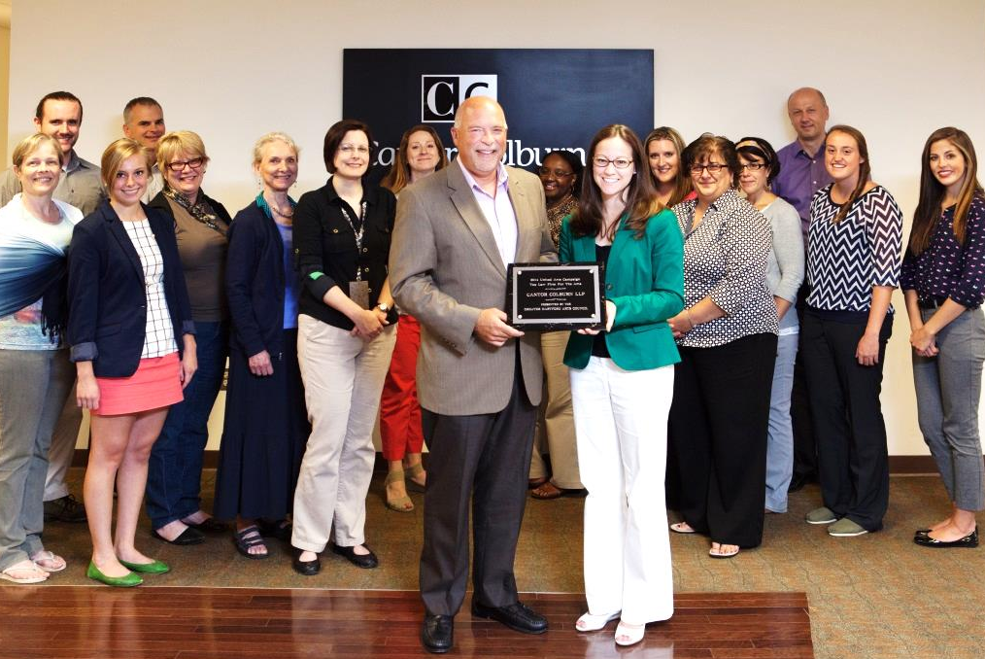

About Cantor Colburn LLP

Cantor Colburn is one of the largest full service intellectual property law firms in the country, with growing offices in Hartford, Washington, D.C., Atlanta, Houston, and Detroit. Cantor Colburn is nationally-ranked in trademarks, patents, and litigation. In 2014, the firm and its attorneys have received numerous accolades, including Intellectual Property Today naming Cantor Colburn 10th out of the Top Patent Firms in the United States and The Connecticut Law Tribune awarding the firm with the Litigation Department of the Year in Intellectual Property. Cantor Colburn’s clients are among the leading companies in the country and around the world, including Fortune 100 companies, privately-held companies, select high tech start-ups, and universities. For more information, go to www.cantorcolburn.com.

###

