Press Release
Contact: Jessica Lister
jlister@cantorcolburn.com
860-286-2929, ext. 1171
June 30, 2014

Cantor Colburn’s Daniel Lent Speaks at
U.S. Bar/JPO Liaison Council Meeting

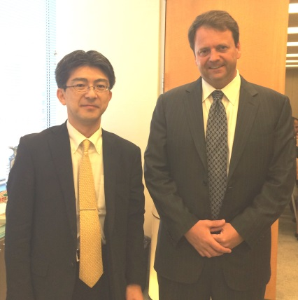
Hartford, Conn.—Cantor Colburn partner and Japanese Practice Group Leader, Daniel P. Lent, spoke before the Commissioner of the Japan Patent Office (JPO), Hideo Hato, and other present JPO officials at the U.S. Bar/JPO Liaison Council June 20, 2014 Meeting.

The meeting took place in Washington, D.C., where it was called to order to discuss the sharing of information on the U.S. and Japanese patent systems and their operational practices. Lent spoke on recent Federal Circuit patent cases.

According to the JPO website, the JPO agreed to continue discussions towards achieving international harmonization of patent laws and systems.

The picture above features Lent (right) and Mr. Shintaro Takahara, Assistant Director General of Policy Planning at the JPO.

About Cantor Colburn LLP

Cantor Colburn is one of the largest full service intellectual property law firms in the country, with growing offices in Hartford, Washington, D.C., Atlanta, Houston, and Detroit. The firm is nationally ranked in trademarks, patents, and litigation. In 2014, the firm and its attorneys have received numerous accolades, including Intellectual Property Today naming Cantor Colburn 10th out of the Top Patent Firms in the United States and The Connecticut Law Tribune awarding the firm with the Litigation Department of the Year. Cantor Colburn’s clients are among the leading companies in the country and around the world, including Fortune 100 companies, privately-held companies, select high tech start-ups, and universities. For more information, go to www.cantorcolburn.com.

###

